Meaning of risk: risk is a term carrying different meaning s to different parties. A motorcyclist is exposed to the risk of accident, a player is exposed to the risk of losing game and an investor is exposed to the risk of losing entirely his or her investment or the risk of earning less than that had been expected. But one common element in all these outcomes is that the risk is undesirable, hence everybody tries to avoid it.
Whenever we are in a situation where the outcome is unknown, we are exposed to risk. In most general terms, risk is defined as the chance of loss. Most of the business decision concerned to rising prices, expansion of production or product lined, and development of new products and so on expose the firm and its owners to risk.
Risk refers to e probabilities that the returns expected form a project may heave alternative outcomes. In project, the risk is defined as variability in returns. The profitability estimate of a project depends on cash flow estimations, which are generally uncertain. Hence, we use the term risk to describe and investment project whose cash flow is not known in advance with absolute certainty. In other words, project risk is condition where there is a possibility of deviation between desired and expected outcome.
Origin or sources of project risk
There are four major sources of risks that affect projects NPW in engineering economic studies.
- Cash flow estimates: the first source is the possible inaccuracy of the cash flow estimates used in the study. The accuracy of the cash inflow and outflow estimate is difficult to determine. If they are based on past experience, a fair degree of reliance may be placed on estimates. Otherwise, the estimate would become more uncertain.
- Nature of business: another source of risk and uncertainty if the type of business involved in the economy. All businesses are not of same nature because some types of business operations are less stable then other. For example, mining enterprises or projects are riskier than farming projects with the expectation of stability and income generation.
- Rate of interest: current health of economy and future expectations of economic conditions are responsible for determining market rate of interest and its stability. Hence, whenever capital is to be invested in an engineering project, an investor should be considered in deciding what risk is present on rate of interest.
- Study period: another risk source is the length of study period used in the analysis. A long study period naturally decreases the probability of all the factors as estimated ie long study period generally increases the uncertainty of capital investment and economic return.

- Break even analysis
Break even analysis is a most common methodology used for economic evaluation of new investment alternatives. It determines the value of a critical factor at which economic tradeoff are balanced. When the equivalent worth of cash inflows and outflows are dependent upon single factor, the value of this factor for which equivalent worth of cash outflows equals the equivalent worth of cash inflows is called breakeven analysis.
Break even analysis for a single project
The costs of producing a good can be split into two main parts
Fixed cost (CF)
Fixed costs are those that remain the same for the firm however many goods are produced. Also startup costs such as land, building, rent, insurance, equipment etc are considered fixed costs since you have to make these outlays before you sell your first item.
Variable costs (Cv)
Variable costs vary with the number of items produced. So, these are recurring costs that you absorb with each unit produce or sell. It includes cost of wages, raw materials, and electric, fuel etc
Total cost (CT) is the sum of fixed cost (CF) and variable cost (CV)
Therefore, CT= Cf+Cv
The linear relationship assumed for the variable costs
Cv= VcX, where Vc = variable cost per unit, X = Quantity of the product
Hence, CT= Cf+Vc(X)
The total sales revenue ST during the same period will be
St=SpX
Where Sp= selling price per unit.
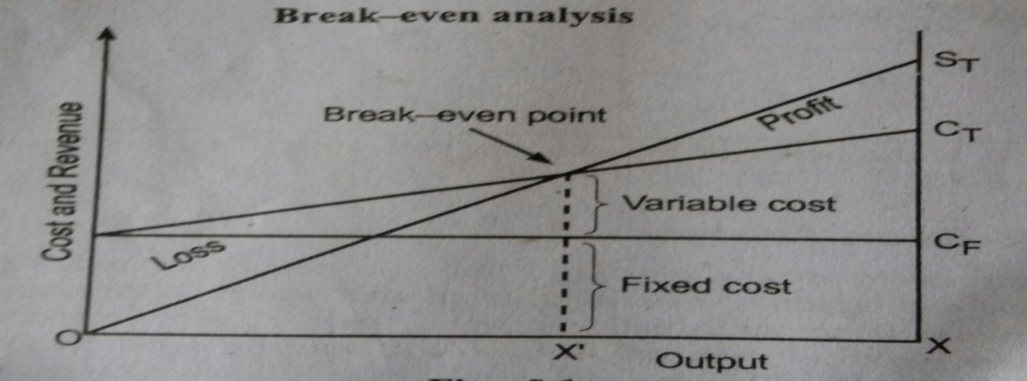
From the economic point of view, the breakeven sales volume is that which ensures all costs are covered by a given quantity sold. Hence, the intersection point of the total sales revenue line (St) and the total cost line (Ct) is called breakeven point. In above figure, at breakeven output volume (X)
St=Ct
Or SpX= Cf+VcX
Or Cf=X(Sp-Vc)

CF
Or X= ------ (units)
Sp-Vc
Obviously, to reach a break-even position, the selling price has to be greater than the variable cost per unit. At the breakeven point, the organization will neither make profit nor incur any loss.
If, the output volume for the time period is greater than X then profit will occur. Similarly, when the output volume is less than X, a loss from operation will be incurred by the organization.

Example: Suppose fixed cost associated with the production of a product is Rs 500000. Assume that the variable cost is Rs 20000 and the selling price is RS 30000 for each product and maximum sales amount is Rs 3000000 when sales volume is 100 units. Determine the breakeven point for this situation and plot the BEP chat.
Solution:
Fixed cost (Cf)= RS 500000
Variable cost per unit (Vc)= Rs 20000
Selling price per unit (Sp)= Rs 30000
Breakeven point (BEP) =?
Solution /Given
Fixed cost Cf= Rs 500000
Variable cost per unit Vc= Rs 20000
Selling price per unit Sp= Rs 30000
BEP=?
We know breakeven point
CF
X= ------ (units)
Sp-Vc
= 500000/(30000-20000 = 50 units
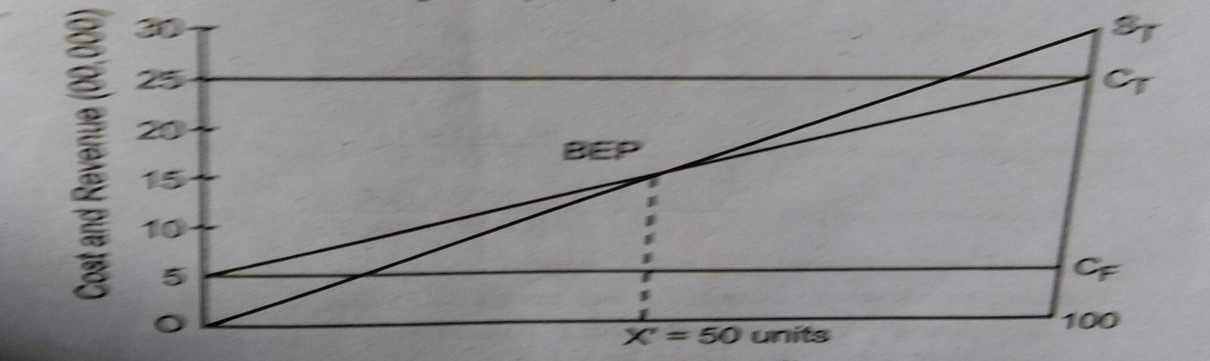
Example : If Sony company wants to producer branded laptops with increasing market demand. The company is estimated following figures
Fixed cost 2000000
Total cost 4000000
Total sales 3000000
Sales quantity 50units
Required
- Breakeven units of production
- What should be the output if company desires to have the profit of Rs 500000?
Break even analysis for comparing two alternatives
When dependent on a single and common factor, we can solve for the value of that factor by equating equivalent worth and which the conclusion is standoff. That value is known as the breakeven point ie the value at which we are indifferent between the two alternatives.
In mathematical terms,
EWA= f1(y) and EWB=f2(y)
Where, EWA =Equivalent worth calculation for the net cash flow of alternative A
EWB= Equivalent worth calculation for the net cash flow of alternative B
Breakeven point is the value of y for which
y= a common factor affecting the equivalent worth values of alternatives A and alternative B
Breakeven point is the value of y for which
f1(y)= f2(y)
Example of common factors (parameters)
- Annual revenue and expenses
Solve for the annual revenue required to equal (breakeven) with annual expenses. Break even annual expenses of an alternative can also be determined in a pair wise comparison when revenues are identical for both alternatives being considered.
- Rate of return: solve for the rate of return on the increment of invested capital at which two given alternatives are equally desirable.
- Salvage value: solve for the future resale value that would result indifference as to preference for an alternative.
- Equipment life: solve for the useful life required for an engineering project to be economically justified (positive net worth)
- Capacity utilization: solve for the hours of utilization per year at which an alternative is justified or at which two alternatives are equally desirable.
Steps to determine breakeven point of common variable
Define the common variable and its dimensional units.
Use pw or aw analysis to express the total cost of cash alternative as a function of the common variable.
Equate the two relations and solve for the breakeven value.
If the anticipated level is below than break even value, select alternative with the higher variable cost. If the anticipated level is above than break even value, select the alternative with lower variable cost.
Example
Consider the following two motors each of 100 hp output capacity
Items Motor A Motor B
Purchase cost 125000 160000
Efficiency 74% 92%
Life 10 10
Maintenance cost per year 5000 2500
Annual tax and insurance 1.5% 1.5%
MARR 15% 15%
Required: a. How many hours per year would the motors have to be operated at full load for the annual costs to be equal? If electricity cost is Rs 5/kwhr
b.. if annual operation is more than 55 hours, which motor should be selected?
Solution:
For motor A:
Calculating the annual equivalent cost
Capital recovery CR cost
=12000(AP, 15%, 10 years) = 24906.5
Maintance cost: Rs 50000
Tax and insurance cost = 1.5% of 125000= 1875
Operating expenses for power (electricity cost)
We know that
Output
Efficiency = -----------------------------------
Input
Input =output/efficiency
Let X be the number of hours of operations per year.
Operating expenses = input x rate x hours
= output/efficiency rate x hours
= output/efficiency rate x hours
= (100x0.746)/0.74 x 5 x X
= 504.05x X note: 1 hp = 0.746 kw
Total amount equivalent cost of motor A(AW of A)
= 24906.5+5000+1875+504.05X
=31781.5+ 504.50X------------------------------- (i)
For motor B
Calculating the annual equivalent cost
- Capital recovery (CR) cost = 160000(AP,15%, 10 years)= 31880.32
- Maintenance cost= 1200
- Tax and insurance = 1.5% of 160000= 2400
- Operating expenses for power
Let X be the number of hours of operation per year
Operating expenses =(100 x 0.746)/0.92 x 5 x X= 405.43 X
Total annual equivalent cost of motor B (AW of B)
=31880.32+2500+405.43X
= 36780.32+405.43X----------------- (ii)
To get breakeven point
AWof A= AW of B
31781.5+ 504.50X = 36780.32+405.43X
X= X= 51 hours per year (breakeven hour)

2. Sensitivity analysis: one way to collect a sense of the possible outcomes of an investment is to perform a sensitivity analysis. Sensitivity analysis determines the effect on the NPW of variations in the input variables such as revenues, operating cost, salvage value, useful life etc. used to estimate after tax cash flows. A sensitivity analysis reveals how much the NPW will change in response to a given change in an input variable. In a calculation of cash flows, some items have problems; the most significant items may be easily identified. For example, the estimate of sales volume is often a major factor in a problem in which the quantity sold varies among t alternatives.
Sensitivity analysis is sometimes called "what if' analysis because it answers questions such as, what if incremental sales are only 1000 units rather than 2000 units? Then what will the NPW will be? Sensitivity analysis begins with the base case situation, which is developed using the most likely values for each input. We then change the specific variables of interest by several specified percentage above and below the most likely value, while holding other variables constant. Next, we calculate a new NPW for each of these values. A convenient and useful way to present the results of a sensitivity analysis is to plot sensitivity graph. The slopes of the lines show how sensitive the NPW is to changes in each of the inputs. The steeper the slope, the more sensitive the NPW is to change in a particular variable. Sensitivity graph identifies the crucial variables that affect the final outcome most.

In engineering economics studies, sensitivity analysis is a general non probabilistic methodology, to provide information about the potential impact of uncertainty in selected factor estimates.
Step for sensitivity analysis
- It begins with the base case situation, which is developed using the most li8kely values for each input.
- Change the specific variable of interest by several specified percentages above and below the most likely value, while holding other variable constant.
- Calculate a new PW/FW/AW/IRR /BCR for each of these values.
- Present the result of a sensitivity analysis in the sensitivity graph.
- The slope of the line shows how sensitive the NPW is to change in each of the inputs.
- The steeper the slope, the more the sensitive the NPW is to change in a particular variable.
Interpretation of sensitivity graph
- On a plot, there are two directions to measure uncertainty
- On X axis, the uncertainty in the input variable is measured.
- On Y axis, the impact of that uncertainty on PW is measured.
- The slope of the line shows how sensitive the PW is to change in each of the inputs. The steeper the slope, the more sensitive the PW is to a change in a particular variable.
- The graph allows us to identify the crucial variables that most affect the final outcome.
Example:
Perform sensitivity analysis of the following project over a range of ±40% in
- Initial investment
- Annual net revenue
- Salvage value
- Useful life
Initial investment = 11500
Net annual revenue = 3000
Salvage value = 1000
Useful life = 6years
MARR = 10%
Draw also a sensitivity graph/diagram
Solution
PW 10% = -11500+3000PVIFA10%6YRS+1000PVIF10%6YRS =2130
- WHEN INITIAL INVESTMENT (I) VARIERS±40% THE PW WOULD BE
AT I = +40%PW= -11500(1.4) + 3000PVIFA10%6YRS+1000PVIF10%6YRS = -2470
AT I = -40%PW= -11500(.6) +3000PVIFA10%6YRS+1000PVIF10%6YRS =6730
- WHEN NET ANNUAL REVENUE AR VARIES VARIERS±40% THE PW WOULD BE
AT AR = +40%= -11500+3000(1.4) PVIFA10%6YRS+1000PVIF10%6YRS =7356
AT AR = -40%=-11500+3000(.75) PVIFA10%6YRS+1000PVIF10%6YRS= -3096
- WHEN SALVAGE (S) VARIES ±40% THE PW WOULD BE
AT S=+40%= -11500 + 3000PVIFA10%6YRS+1000(1.4) PVIF10%6YRS =2356
AT S = -40%= -11500 + 3000PVIFA10%6YRS+1000(.75) PVIF10%6YRS =1904
- WHEN LIFE (N)VARIES ±40% THE PW WOULD BE
AT N = -40%= -11500 + 3000PVIFA10%6(1.4) YRS+1000PVIF10%6(1.4) YRS =5476
AT N = -40%= -11500 + 3000PVIFA10%6(.75) YRS+1000PVIF10 % (.75) YRS =-2077

CALCULATION TABLE
@10%MARR
PARAMITERS | -40% | 0% | +40%
INVESTMENT | 6730 | 2130 | -2470
ANNUAL REVENUE | -3096 | 2130 | 7356
SALVAGE VALUE | 1904 | 2130 | 2356
LIFE | 2077 | 2130 | 5476

Plotting these values in sensitivity graph

Result interpretation
On the basis of calculation table and sensitivity diagram annual revenue parameter of the project is highly sensitive when compare to other parameters. AR curve is steeper than other in diagram. It is followed by investment parameter and useful life parameter respectively.
Salvage value parameter is the least sensitive on his particular project.

3.. Scenario analysis: sensitivity and break-even analysis are useful to show the effect of one common variable and NPW. But it is difficult to specify precisely the relationship between a particular variable and the NPW because in reality there may be inter dependence between the variable. Hence, the relationship is further complicated by inter dependencies among the variables at time.
Scenario analysis is a technique that considers that sensitivity of NPW due to change in key variables at a time and the range of likely values of those variables. For example, the decision maker may examine two extreme cases a worst-case scenario (low sales/price/high cost and so on) and a best-case scenario (high sales/price/low cost and so on)
The NPWS under the worse and the best scenarios are then calculated and compared with the expected NPW.
EXAMPLE
From the following information of different variables or parameters and cases calculate NPW for each scenario by assuming I= 125000, MARR = 15% and unit of demand fixed cost for five years are equal.
Variables | Worst case scenario | Most likely case | Best case scenario
Unit demand | 1600 | 2000 | 2400
Unit price | 48 | 50 | 53
Variable cost Rs/unit | 17 | 15 | 12
Fixed cost | 11000 | 10000 | 8000
Salvage value | 30000 | 40000 | 50000
Solution Worst case scenario
NPW15% = -125000+ (1600X48-1600X17-11000) PVIFA15%5YRS+30000PVIF15%5YRS =19311
- Most likely case scenario
NPW15% = -125000+ (2000X50-2000X15-10000) PVIFA15%5YRS+40000PVIF15%5YRS =96020
- Best case scenario
NPW10% =-125000+ (2400X53-2400X12-8000) +50000PVIF15%5YRS =202899
Certainty: it is defined as a state of knowledge in which the decision maker knows in advance the specific outcome to which each alternative will invariably lead. So, under certainly, decision maker has perfect knowledge about future result of whatever decision he might take.
Risk: it is defined as the state of knowledge in which decision maker can predict different alternatives and each alternative leads to one set of outcome and probability of their occurrence is known. So, risk refers to a situation where a project has a number of possible alternative outcomes, but the probability of each occurring is known.
Uncertainty: it is a state in which there are so many alternatives whose probability can be estimated ie it is decision situation where several states or alternatives are possible but sufficient information is not available to assign probability values to their occurrence.
Project funding mechanism
There are three types of project funding mechanism
- Government investment
- Private investment
- Public private partnership

Decision tree analysis
A decision tree is a graphic device of a decision-making process
It is a graphical presentation of the alternatives
It is also known as tree diagram

Example: a glass factory that specializes in Crystal is developing a substantial backlog and for this the firm's management is considering three courses of actions. The correct choice depends largely upon the future demand, which may be low, medium and high.
Show this decision situation in the form of a decision tree and indicate the most preferred decision and its corresponding expected value.
Demand Probability S1 S2 S3
Low 0.10 10 -20 -150
Medium 0.50 50 60 20
High 0.40 50 100 200
Where,
S1 = sub contracting
S2= being overtime
S3= construct new facility
Solution
Procedure
1. To calculate expected monetary value using probability
2. Draw the diagram
3. Select the best alternative
Expected monetary value EMV (S1) = .10x10+.50x50+.4x50 = 46
Expected monetary value EMV (S2) =.10x(-20)+.60x50+.4x100 = 68
Expected monetary value EMV (S3) =.10x(-150)+.50x20+.4x200 = 75

As per decision tree analysis S3 is selected because it has higher expected monetary value.

Monte Carlo Simulation Technique
Simulation
Simulation is the process of designing a model of a real system and conducting experiments with the model for the purpose of understanding the behavior for the operation of these system.
A duplication of the original system
To understand the implementation of the system
This method is used by various types of organizations, for their different uses.
a. As per different business situation
b. For inventory control
c. Financial decision etc

Monte Carlo Simulation Technique
It is and experiment on chance (probability)
Uses random number and requires decision making under uncertainties.
Understand of this technique
To understand this technique, this is break down into five steps
1. Establishing probability distribution
2. Cumulative probability distribution
3. Setting random number intervals
4. Generating random numbers
5. To find the answer of question asked using the above four steps
Example: Strong is a dentist who schedules all her patients for 30 minutes appointments. Some of the patients take more or less than 30 min depending on the type of dental work to be done. The following summary shows the various categories of work, their probabilities and the time actually needed to complete the work
Category Time req No of patients Probability
Filling 45 min 40 .40
Crown 60 min 15 .15
Cleaning 15 min 15 .15
Extracting 45 min 10 .10
Checkup 15 min 20 .20
Simulate the dentist's clinic for four hours and find out the average waiting time for the patient as well as the idleness of the doctor. Assume that all the patients show up at the clinic ate exactly their scheduled, arrival time staring at 8 am.
Use the following random numbers for handling the above problem
40,82,11,34,25,66,17,79

Step one: establishing probability distribution (probability)
Probability = favorable outcome /total outcomes
Step 2: cumulative probability distribution
Solution
Category Probability Cu probability Random no
Filling .40 .4 00-39
Crown .15 .55 40-54
Cleaning .15 .70 55-69
Extracting .10 .80 70-79
Checkup .20 1 80-99

Patient Scheduled arrived Random number Category Service time
1 8.00 40 Crown 60 min
2 8.30 82 Checkup 15 min
3 9.00 11 Filling 45 min
4 9.30 34 Filling 45 min
5 10.00 25 Filling 45 min
6 10.30 66 Cleaning 15 min
7 11.00 17 Filling 45 min
8 11.30 79 Extracting 45 min

Final table for answers
Patient Arrival Service start Service duration Service ends Waiting in min Idle time
1 8.00 8.00 60 min 9.00 0 0
2 8.30 9.00 15 min 9.15 30 0
3 9.00 9.15 45 min 10.00 15 0
4 9.30 10.00 45 min 10.45 30 0
5 10.00 10.45 45 min 11.30 45 0
6 10.30 11.30 15 min 11.45 60 0
7 11.00 11.45 45 min 12.30 45 0
8 11.30 12.30 45 min 1.15 60 0
Total 285 min

Average waiting time = total time /number of patients
= 285/8 = 35.625 minutes
Idle time of the doctor is 0 minutes

